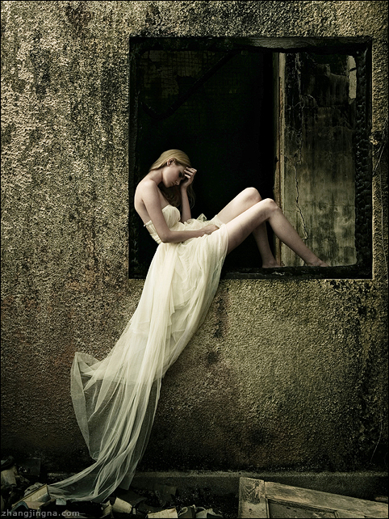

<http://www.deviantart.com/art/Forgotten-Fairytales-58397032>

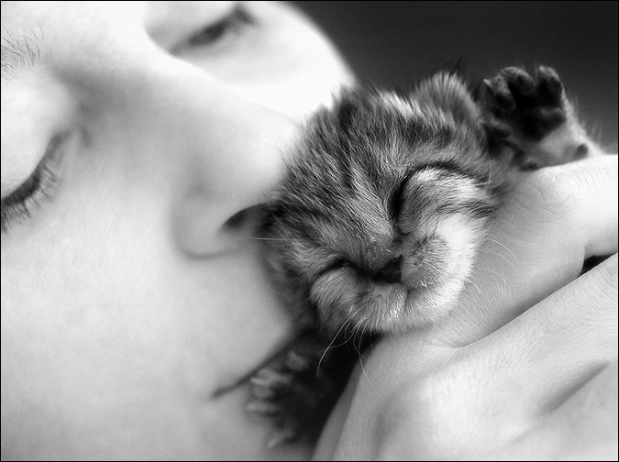

<http://www.deviantart.com/art/because-we-share-life-16216518>

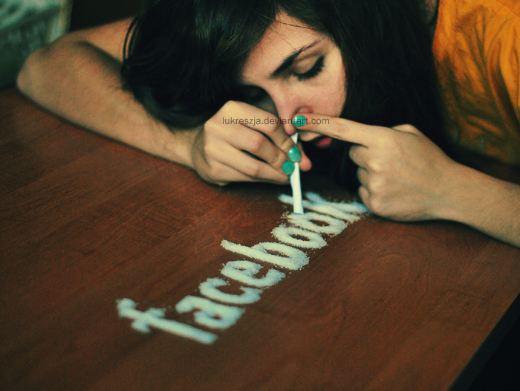

<http://www.deviantart.com/art/XXI-century-drug-197126336>

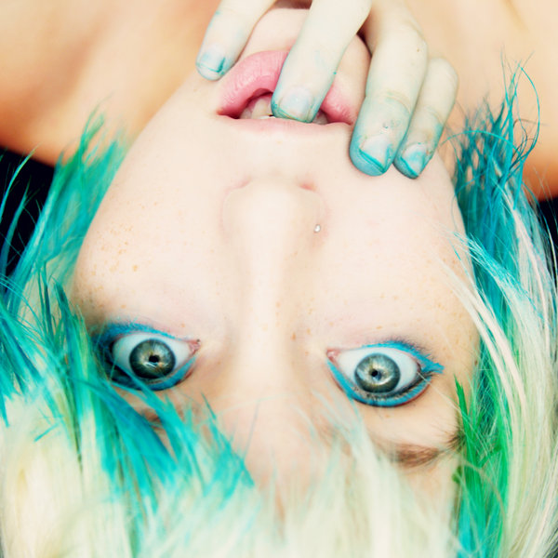

<http://www.deviantart.com/art/my-strange-condition-135349720>

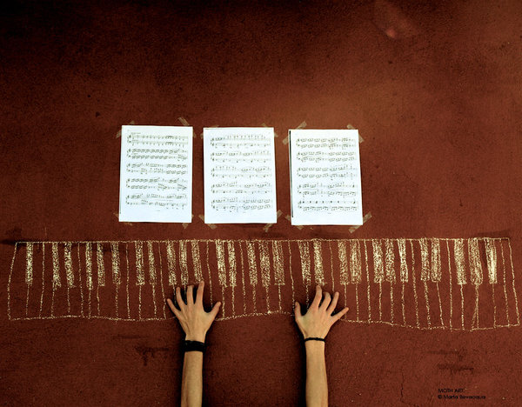

<http://www.deviantart.com/art/all-we-need-is-music-116952480>

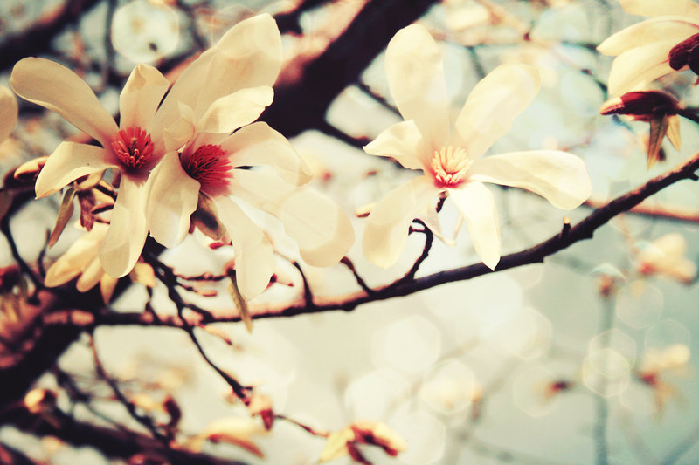

<http://www.deviantart.com/art/Magnolia-80162272>

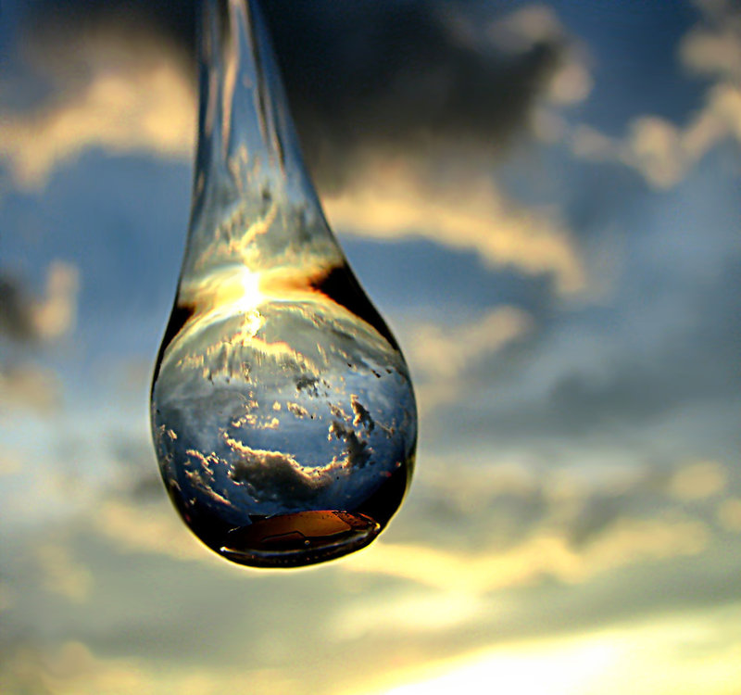

<http://www.deviantart.com/art/Crystal-Sunset-103535160>

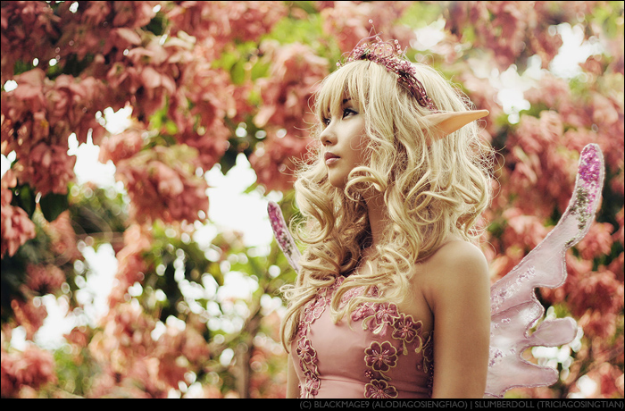

<http://www.deviantart.com/art/An-Elven-Fairy-s-Backyard-86655096>

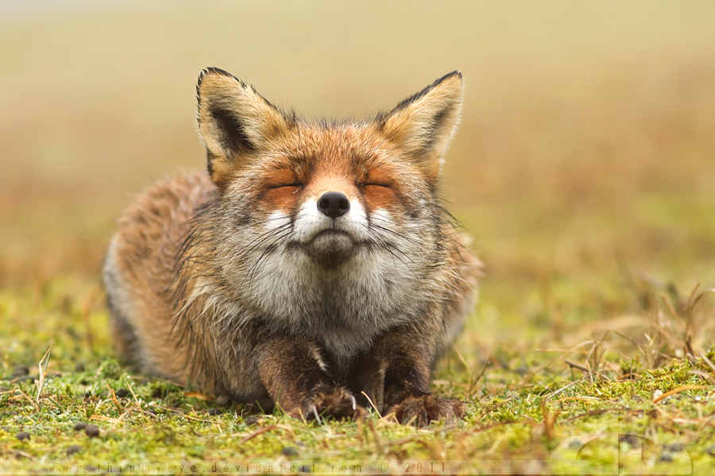

<http://www.deviantart.com/art/A-l-aise-197858159>

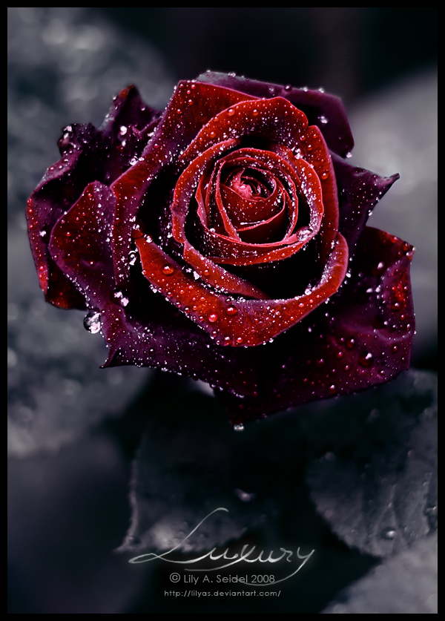

http://www.deviantart.com/art/Luxury-89432405